1. What is it ?
2. Rabbit
3. Butterfly
4. Ant
5. Tiger
6. What is it ?
7. Orange
8. Apple
9. Avocado
10. Starfruit
11. What is it ?
12. Paper
13. Yoyo
14. Candy
15. Egg
16. We say ….. for this alphabet
17. Ji
18. Eich
19. Ai
20. Jei
21. We say … for this alphabet
22. Ei
23. Kyu
24. Wai
25. Dabelyu
26. We say for this alphabet
27. Ai
28. Ei
29. I
30. Pi
31. What is it?
32. Tiger
33. Dog
34. Cat
35. Worm
36. What is it?
37. Durian
38. Orange
39. Jackfruit
40. Watermelon
41. 
42. Two ballons
43. Three ballons
44. Four ballons
45. Five ballons



1. Five tables
2. Six tables
3. Seven tables
4. Eight tables
5. Write the numbers
6. Seven

**9**

1. Eight
2. Four
3. Five
4. Write the numbers (8)
5. Seven

**8**

1. Eight
2. Nine
3. Ten
4. Write the number (6)
5. Six

**6**

1. Seven
2. Eight
3. Nine



1. Eight horses
2. Nine horses
3. Ten horses
4. Eleven horses
5. Six plus four is ……
6. Nine
7. Ten
8. Eleven
9. Twelve
10. Two plus five is……..
11. Seven
12. Eight
13. Nine
14. Ten
15. Apa warna jeruk ?
16. Green
17. Orange
18. Black
19. White
20. Apa warna alpukat ?
21. Green
22. Yellow
23. Black
24. White
25. 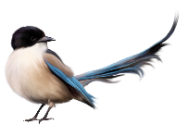What is it ?

It is……..

1. Giraffe
2. Elepanth
3. Bird
4. Mouse
5. 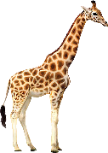What is it?

It is…..

1. Giraffe
2. Edog
3. Cow
4. Tiger